iPads in the Classroom for Students with Visual Impairment

Join.me is a free screen sharing app. The student will download the joinme app on the iPad and the teacher will download join.me to their computer. Anything presented on the smartboard will appear on the student’s screen. FREE
- Have the student download joinme from the Apple app store
- On your classroom computer, go to www.joinme.com
- Click “Get Started” and create a login
- Skip through the customize selections and click “Download join.me”
- This will be a free 14 day trial of the Pro Version. After the trial period you will have the option to keep using the basic free version which is all you’ll need.
- After download is complete click the desktop icon for join.me
- Start meeting using the one time code option
- You will see a code at the top of your screen similar to this (809-934-738)
- Give your student this code to input on the iPad
- That's it, your student can now share your screen until one of you disconnects
- Now that you have an account you will just sign in and start a meeting in the future to get the code. It's very quick and easy.

How to screen share from an iPad to a SmartTV using AppleTV:
- On the teacher’s iPad, swipe from the upper right corner and click “Screen Mirroring” and select the AppleTV.
- Start Join.Me meeting on the teacher’s iPad. Have the student join with the code on your iPad
- On Teacher iPad click the arrow in the upper left hand corner, select “start new whiteboard”. Here you can import pictures of worksheets to annotate or write on a blank page.
- It’s important to note you cannot do full screen sharing from iPad to iPad. If you have a Powerpoint, website or any presentation other than a whiteboard in join.me you’ll need to use a computer so the student may join and access it on their iPad.
With Genius Scan on your iPad or iPhone, students have their own personal scanner! They can take a picture of a worksheet or document, save in pdf format and open in Notability to complete the assignment. FREE
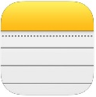
With the Notes app on your iPad or iPhone, students can also scan documents.
    - Start a new note by clicking the icon in the bottom right that looks like a pencil & paper
    - Click the “+” icon at the bottom middle of your screen
    - Click “Scan Documents” and hold your iPad over the document. It will automatically locate your document and take the picture (it’s helpful to place the document on a clean contrasting surface)
    - Click Save
    - Click the arrow in the upper right and find copy to notability
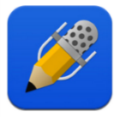
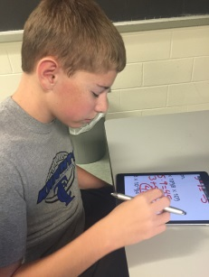
With the Notability app, teachers can email a student the worksheet, the student can complete it on the iPad by typing , marking, highlighting, save and then return via email to the teacher. Notability also has the capability to create folders and dividers allowing the student to organize and save their work. For example, the student could make a folder for all classes and file assignments appropriately creating an online notebook. $5.99
Genius Scan

- Open Genius Scan app
- Select camera
- Take picture of worksheet
- Click button on bottom (box with arrow) right of iPad Screen
- Select Format as PDF
- Scroll down to “Export to” and select “Other Apps”
  - Choose “Open in Notability”. If you it does not automatically open the app. You’ll have to go to the main screen and tap to open Notability.

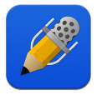
Notability

- Open notability after sending document from Genius Scan
- An import window will come up, tap create a new note and open
- Now you’re ready to mark, highlight, type or record using the icons at the top of the screen
- When ready to email assignment to the teacher, click the box with the arrow at the upper left of the screen, select email (if you included recordings, make sure that is selected here)
- Click email notes, type in address and send
- Organizing notes in notability: You can create subject folders and dividers, resulting in an electronic notebook for the student. See the instructions attached for organizing notes.
Organizing notes is an important aspect of note-taking. The Library can be used to sort notes into logical groups using subjects. Subjects can be grouped using dividers.
Create a new subject
- Tap +
- Select subject
- Enter a title
- Tap done on the keyboard

Create a new divider
- Tap +
- Select divider
- Enter a title
- Tap done on the keyboard

Moving notes
Notes can be moved into subjects
- Tap and hold a note thumbnail
- Drag the note to the desired subject
Notes can also be batch moved on iPad.

Deleting notes
- Swipe with a finger from right to left on the note and tap delete.
- To search for a note by title or content, tap and enter a search term.

